ALL ABOUT US - St Mary’s Information Book
Welcome from the Principal

I would like to thank you for your interest in St Mary’s Primary School. St Mary’s is a Catholic Parish Primary School serving the families of Cohuna and surrounding suburbs. St Mary’s is an intimate primary school of approximately 120 Learners and we pride ourselves on our ability to personalise our learning. We are proud of our learning environment which aims to provide contemporary practices and current educational methodology for our Learners. We have 1:1 devices throughout the school, we integrate such tools into our teaching to engage our learners and encourage them to be responsible digital citizens. St Mary’s offers specialist curriculum such as The Arts (Performing & Visual), Physical Education, and our ‘Language Other Than English’ is Italian. Due to our class sizes, we are able to share expertise and resources so that our Learners' needs are being targeted and driven by data regularly.
Our Pastoral Wellbeing approach in conjunction with our Positive Student Behaviour Policy, promotes positive self awareness of all in our community. Our learning spaces are large and attractive, both heated and cooled in relative seasons. Our grounds are pristine with large playing areas, and a variety of equipment for Learner choice. Our grounds are inclusive of all interests and imagination and provide space for our Learners to grow and enjoy themselves. Our school actively encourages engagement with parents and the wider community. We strongly believe that working in partnership is crucial to building positive learning relationships for our Learners. The educators of St Mary’s are passionate and dedicated and recognise that every child learns differently. The staff of St Mary’s are committed to the education of the children and seek to maximise the potential of all Learners who attend St Mary’s.
We welcome you to visit our school.
Jarrod Mullavey
Our Identity Statement
At St Mary's all will be included, nurtured, faith filled, respected and inspired to reach their full potential.
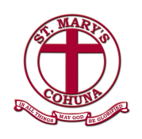
Our Graduate Outcomes
- Confident
- Compassionate
- Respectful
- Resilient
- Life Long Learners
Our Motto
In all things may God be Glorified

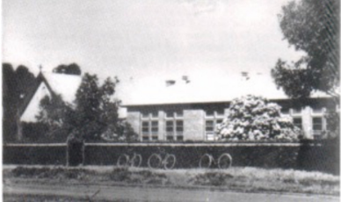

Our History
St. Mary's School, Cohuna was opened by the Sisters of the Good Samaritan in 1926, with an approximate enrolment of 60. In those days, Primary Education extended to 8th grade - The Merit certificate. Within a few years, a need arose to extend the school further to Intermediate. The school continued this extended education until 1964, when it reverted to its present primary system - Prep to Gr. 6.
In former days the school was known as the Immaculate Conception, but once the Parish was established in 1936, the school’s name was changed to the above, and the Parish maintained the original title - "Immaculate Conception".
Our Parish
St Mary's Primary school and St Mary's Parish work collaboratively within the community. In April 2022, Father Dean Bongat was appointed Parish Priest of St Mary's Cohuna, St Joseph’s Kerang and St Patrick’s Pyramid Hill. Father Dean is an active presence in our school and Church.
St Mary's weekly Mass times are as follows:
Tuesday 9:15am and Sunday 8:30am (every second Sunday of the month @10:30am)

Our Religious Education Program
St Mary’s integrates the Source of Life program into the curriculum daily. The Source of Life is a program designed by the Diocese of Sandhurst and is delivered for approximately two and a half hours a week. Prayer, liturgy and attendance to Mass is also an integral part to one’s faith development and the school partakes in such traditions regularly. All Learners enrolled at St Mary’s are taught Religious Education and are expected to take part in these rituals and traditions. Concepts, values and key messages taught in Religious Education underpin all that we say and do.
An individual’s Religious Education is a lifelong process and attending a Catholic School only enhances this. Religious Education in the 21st Century aims to;
- Foster within each individual a relationship with God
- Immerse children in the story of the Catholic Faith Traditions and to understand the faith traditions in others
- Create better self knowledge and spiritual growth
- Actively commit to acts of social justice and Reconciliation and recognise that these are grounded in the story of Jesus
- Nurture the faith and spiritual journey of all at St Mary's.

Our Sacramental Program
St Mary’s offers a Sacramental program annually to its age appropriate Candidates. A Sacramental Candidate must have been baptised in a Catholic Church for this faith journey to continue in the Catholic Church. Anyone interested in the possibility of Baptism should contact the Sacramental Leader within the parish.
The Sacrament of Reconciliation is offered for Learners in Years 3 and beyond for those who have previously been baptised.
The Sacrament of First Eucharist and Confirmation is offered for Learners in Years 4 and beyond for those who have previously been baptised and received Reconciliation.
Our program is taught within the school's RE curriculum with family home tasks and support.
Young members of the Catholic faith within our community are welcome to take part in St Mary's Sacramental Program. Please contact the parish for further information.

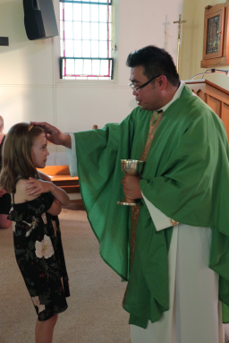

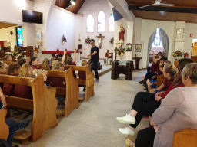

Our Learning & Teaching Program
At St Mary's we employ an Inquiry based approach to learning within an integrated curriculum, developing the knowledge, skills and dispositions outlined by the Victorian Curriculum. In preparing our Learners for the future, we recognise the importance of developing their capacity to learn how to learn. Our inquiry approach draws on a range of tools and strategies to develop the Learners thinking, inquiring, researching, communication and self management skills. We use various models of inquiry including project, challenge and interest based investigations which reflect a commitment to create learning opportunities and experiences that become an adventure for our Learners to explore, understand and interact with our world. Each term our Learners embark on an Inquiry which is a cross curricular, inquiry based investigation that aims to develop a cumulative understanding of the many learning areas and capabilities noted in Victorian Curriculum:

LEARNING AREAS & CAPABILITIES
English | Mathematics | Science | Health & Physical Education
Technologies | The Arts | The Humanities | Languages
Critical & Creative Thinking | Ethical | Intercultural | Personal & Social

Each Inquiry is launched with an open ended investigation question(s) and relevant key understandings. The knowledge, skills and thinking strategies incorporated aim to provide a balance between curriculum outcomes, real life contexts, current affairs and Learner interests. Our inquiry process is an investigation scaffold that supports Learners as they move from the known to the unknown in the pursuit of deep learning, deep understanding and the application of their new learning to other situations.

Our Learning & Teaching program includes: English, Mathematics, Religious Education, Inquiry, Italian, Art: Performing & Visual, Physical Education and Library. ICT is integrated across all curriculum levels.
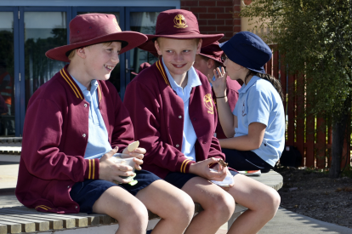

Home School Communication
Communication is paramount to successful relationships. The staff and teachers at St Mary’s strive to keep parents informed about the happenings at school at every opportunity. To ensure all avenues of communication are available, the school provides weekly newsletters, home / school diaries, telephone calls / SMS, PAM (Parent Access Module), parent information sessions, learning conversations, Seesaw, Facebook, paper correspondence to those who request it and the school website. If however, any parent has any queries relating to the operation of the school and the wellbeing of your child(ren), please do not hesitate to contact the school and make an appointment with the Principal or the class teacher.
School Stream
Our school App, which can be downloaded from the App Store or Google Play is called School Stream. Simply search for 'St Mary's Cohuna' to be kept up to date with the daily runnings of our school. The App houses permission notes, events, a
calendar, reminders and documents such as our weekly newsletter and Canteen menu.
PAM
St Mary’s use an online portal called SIMON. This resource informs staff and learners of daily organisation, calendar events, reports, behaviour tracking and personal profiles such as attendance and medical records. PAM is the parent portal that offers access to the same information. It ensures that our families have access to school links and key documentation important for our community.
All families are provided with a Username and Password for access their child(rens) PAM account(s).
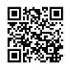
Our Website
St Mary's website also provides communication, forms, policies and procedures that may be of use. We aim to keep our website current to ensure our community can access information readily. Use a QR Reader App to access our website from this QR Code.

Assessment & Reporting
St Mary’s uses a variety of assessment tools to gather data on the progress of individual Learners. We follow a formal assessment schedule throughout the year to ensure our Learners are being taught at the required and personalised levels. The data is used and analysed regularly to inform our teaching practices. Assessment is regularly discussed in a collaborative setting to ensure we are meeting the needs of our individual Learners and using all teaching expertise available. Data driven teaching is expected at St Mary's. Assessment tools used are; anecdotal records, checklists, moderated work samples, diagnostic tests, observations, peer and self assessment protocols, conferences and assignments.

Learning Conversations
Parents, teachers and Learners will meet each term to discuss the progress of their learning journey. In Term One, the conversation provides parents with the opportunity to share information about their child, with any questions or concerns that they may have. Learning conversations are scheduled each term thereafter. These conversations are directly related to your child’s learning, identifying strengths and challenges and the partnership of school and home that will allow all children to celebrate great success. We believe these opportunities model to the child the importance of being active in their learning.
Reports
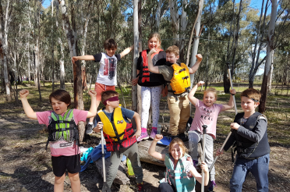
A school report aims to document a Learner's growth and achievements each semester. It communicates learning and teaching information to home, relevant to the individual learner. Reports aim to describe what each child has achieved and how he or she has gone about their learning as well as providing recommendations for future learning. Written reports are distributed twice a year, at the end of each semester. A learning conversation is an additional opportunity to discuss your child’s report if you have any queries.
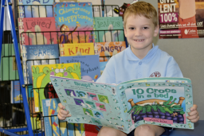

Excursions & Incursions
Our Learners take part in excursions and incursions which deepen their learning experiences. Sometimes the richest learning experience happens outside the classroom. Throughout the school year the Learners also take part in cultural and community events such as concerts, plays, assemblies and learning with others. These events allow for immersion and exposure to experiences gained outside of a normal school setting. Signed parent permission must be provided for the Learners to take part in all external learning experiences. This is a legal requirement.
Our Camp Program
Our Learners take part in a Camp program from Prep. It aims to be a progressive program where independence, collaboration and confidence is encouraged.
Prep & Year 1: A long stay at school one evening
Year 2: One night away
Year 3 & 4 : One - Two nights away
Year 5 & 6 : Three - Four nights away

Parent Involvement
Parents are their child’s first and most important teachers
Parents are an integral part of their child’s education and there are many ways in which parents can involve themselves in their child’s school life. Parents can actively participate through assisting in the classroom, parent learning support, attending school Masses and learning events, volunteer to assist with reading during RATS, attend school working functions and celebrations, join the Parents and Friends Association or the School Advisory Council, attend sports days and excursions or simply enjoy the social functions offered throughout the year. Children thrive when they know their parents have an interest in their life at school.
St Mary’s Primary school adheres to all Child Safe standards and legislation, and encourages all parents to get a Working With Children’s Check which is free if volunteering in the school. The completion of a WWCC and St Mary's Child Safe Volunteer application forms must be completed by all volunteers that visit and support the school. All forms can be obtained from our website or enrolment packs.
The Parents & Friends Association
The P&F is an essential part of school for both social events and the financial support that it provides. The P&F provides opportunities for all of us to socialise in the community, come together and work collectively for a common goal. The funds raised by the P&F are always spent improving educational opportunities for our Learners. We welcome anyone into our P&F and are proud of our strong sense of community.

The School Advisory Council
St Mary's School Advisory Council is founded on the philosophy of Shared Wisdom. St Mary's School Advisory Council plays an important role in the collaboration of decision making that impacts the school’s future direction. The Strategic Plan provides a scaffold for school renewal and improvement and is an active document referred to continually by the school council.

School Fees
The fees and levies collected at St Mary’s Primary School are essential in providing high quality education for your child(ren). Each family in the school will be issued school fees that cover costs associated with the education of your child(ren). The fees specifically cover; providing essential resources, materials, facilities and equipment. Finances are needed to maintain and develop the school grounds as well as pay for essential utilities and insurance.
St Mary’s fee structure is broken up into a family fee, a learning levy (books, stationary, ICT leases & maintenance), a learning experience levy and a capital maintenance levy. The family fee is paid once annually per family.
Annually, Catholic school fees increase by approximately 5.9%. At times these fees are subsidised to reduce the family fee and the school will inform you of this at the beginning of each year. The fee schedule for each year is made available in Term Four. It is our endeavour to collect all annual school fees so that St Mary's Primary School can continue to offer your child the best possible education. School fees can be paid in a variety of forms and payment arrangements are tailored to families needs. St Mary's adheres to its Fee Policy and Procedures. Our fee policy is available on our website and on PAM.

If you are not willing to learn, No one can help you.
If you are determined to learn, No one can stop you!
Kushandwizdom

Supervision of our Learners
The school grounds will be supervised between 8:30am - 8:45am. Staff are on the premises prior to this time however are not in a supervisory role. Learning space doors open at 8:30am, ready for the school day and conclude at 3:15pm. Staff will supervise the grounds until all children have been collected or
up until 3:30pm. Although formal supervision duty ceases at 3.30pm, teachers will be available should unexpected circumstances arise.
Learners are supervised by teachers from 8.30am until 3.30pm. A teacher is rostered on duty at each break, in the morning and when learners are departing. As there is no supervision before 8.30am, we ask that children do not arrive at school before this time.
During wet or particularly hot weather periods children are supervised in their learning spaces at recess and lunch times, where they are encouraged to participate in indoor activities.
School Attendance
It is the responsibility of the parents/carers to ensure their child attends school each day. Everyday at school counts. We ask that every effort is made to have your child at school on time as late arrival interrupts many Learners and can have a detrimental effect on your child's learning. Attendance is marked twice daily on the electronic class roll. This is a legal document and the school is mandated to record all Learners attendances and absences. St Mary's will track attendance data and follow processes and procedures to govern this.
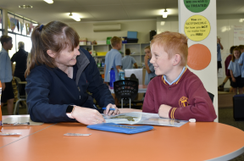
Absence
If your child is not attending school please contact the office by using the absentee form on the App or please phone or email. If communication is not received by 10:30am, the school is legally required to make contact with home for an explanation of absence. Where possible please provide the school with written notification of any upcoming and pre planned absences. The Principal must receive written notification if a Learner is to be absent from school for any extended period, such as a family holiday.
It is important to inform the school of the reason for all Learner absences as the school has an obligation to:
- Determine, if the Learner's absence is in line with St Mary's attendance policy and government guidelines.
- Determine, the appropriate follow up to ensure the Learner’s education and wellbeing is supported.
- Record the reason as to why the Learner is not attending school.
- Monitor and track absence in relation to learning
Excursions, camps and sporting carnivals are part of the school’s curriculum and therefore opting not to participate is not considered a valid reason for a Learner's absence.

Late Arrival & Early Departures
Late Arrival: Any Learners arriving after 8:45am must be signed in at the front office before going to the classroom. A late pass will be given to the Learner to give to the teacher.
Early Departure: Learners leaving early must be signed out at the office by a parent or guardian over the age of 18. A staff member will collect them from the classroom to minimise disruption to other Learners.
Please note: No Learner is legally allowed to leave the premises without written consent from a parent or guardian. Phone calls are not legally binding.

Traveling to and from school
Learners who arrive at school on a bus will enter at the Channel Street entrance of the school and walk to their classrooms.
Learners arriving by car may be dropped off at the front of the school in King Edward Street.
Learners arriving by bike / scooter or by foot may arrive via either Channel Street or King Edward Street. Learners may not ride bikes / scooters in the playground or when crossing roads at any time and are required to wear a helmet.
Any child / family walking in Channel Street are to use the flagged crossing provided. Learners who are collected from school by their parents must wait inside the school grounds.
Bus Travelers
Learners assemble on the basketball court and are supervised by staff until all Learners have departed.
Learners leaving by bike or by foot depart via the above mentioned exits.
Learners who wait to be picked up are to be collected inside the front school gate. Annually, families complete a form outlining daily travel arrangements.

Prep Transition
St Mary's recognises school Transition as a fundamental milestone in a child’s life. St Mary's Transition program aspires to introduce the child to the community of St Mary's in a strategic and explicit way. Through a weekly and progressive session in Term Four, all new enrolments will meet all of the St Mary's staff in the school, be given a Senior Buddy for initial familiarity and tour all areas of the school to ensure comfort and a sense of belonging. St Mary's Transition program is one we value immensely. All dates and times of Transition sessions will be sent out in Enrolment packs once enrolment applications are complete.

Information for Prep Enrolment
Open Day / Evening: May 4th 2022
Catholic Education Week - May 3rd-7th 2022
Active Family Tours:
Interested families book a tour and have a family interview with the Principal, collect an enrolment pack from St Mary's or download from our website.
Application for Enrolment :
Please submit completed Enrolment Forms and supporting documentation t o St Mary’s by the end of August.

Uniforms
 | BOYS | GIRLS
SUMMER | Navy shorts, school logo polo shirt, white socks, black school shoes | School dress or navy shorts/skorts, school logo polo shirt, white socks, black school shoes
WINTER | Long navy trousers, long sleeve polo shirt, maroon school bomber jacket / windcheater, white socks | Long navy trousers, long sleeve polo shirt. Navy skirt / tunic, maroon school bomber jacket / windcheater, white socks or navy tights
SPORT | Navy shorts, school polo shirt, white socks and runners. Children may wear their navy tracksuit pants or shorts and school polo shirt in cooler  weather. | Navy shorts or skorts, school polo shirt, white socks and runners. Children may wear their navy tracksuit pants or shorts, school polo shirt in cooler weather.

Uniforms are compulsory for all Learners at St Mary's. Learners out of uniform must have a note supplied by their parents.
St Mary's school hats are supplied for Prep Learners when they begin school. Hats are worn in terms 1 and 4. Hats are kept at school and can be purchased from the uniform shop if a replacement is needed. All school uniforms are available to be purchased from CDFPay.
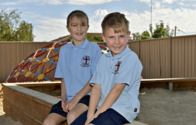
School Buses
Learners who live more than 4.8kms from St Mary's are entitled to travel on government buses free of charge. An application form for approval to travel is available from the office which upon completion is forwarded by the Principal to the local bus co-ordinator at Cohuna Secondary College. Bus passes are required for Learners going on different buses. Bus passes are only allowed for special circumstances; they are not a mode of free travel. School Bus pick-up from St. Mary's at the conclusion of the day is 3.20pm.
Bicycle & Scooter
It is strongly recommended by the Road Traffic Authority that children under the age of 9 not be permitted to ride unaccompanied on the road. Learners who ride bicycles/scooters to school must know the road rules, have a safe, roadworthy bike/scooter and wear an approved helmet. Learners are not permitted to ride their bikes/scooters in the playground unless as part of a Bike Education Program. Bicycles and scooters are to be stowed in the bike racks provided.
Canteen
St Mary’s Canteen is available every Monday, Wednesday and Friday. The menu changes each term and is planned in advance, with a focus on good nutrition and healthy eating. Mrs Edge works tirelessly to plan and provide a variety of delicious meals for our Learners. Our termly menus can be found on our App, PAM or Website.

Learner Supplies
St Mary’s learning levy covers costs for all classroom items, books and stationaries. Each Learner is to come to school at the start of the year with;
- An Art Smock
- A set of headphones
We ask that all items are clearly labeled.
Assemblies
St Mary’s has a whole school assembly on the last Friday of the month. Our assemblies aim to celebrate and share the learning that is taking place in our school. The assembly is held in the Church or COLA area depending on the season. We encourage parents to attend such occasions. School assembly begins at 2:20pm on these days to allow enough time for dismissal.
CDF Pay
St Mary's aims to be a cashless organisation. St Mary's uses CDF Pay to process canteen, uniform and costs associated with events and gatherings. Simply create an account for your use. There is a direct link to CDFPay on our website.
https://smcohuna.cdfpay.org.au/

